PROJECT-32
AI Appointment Booking Agent
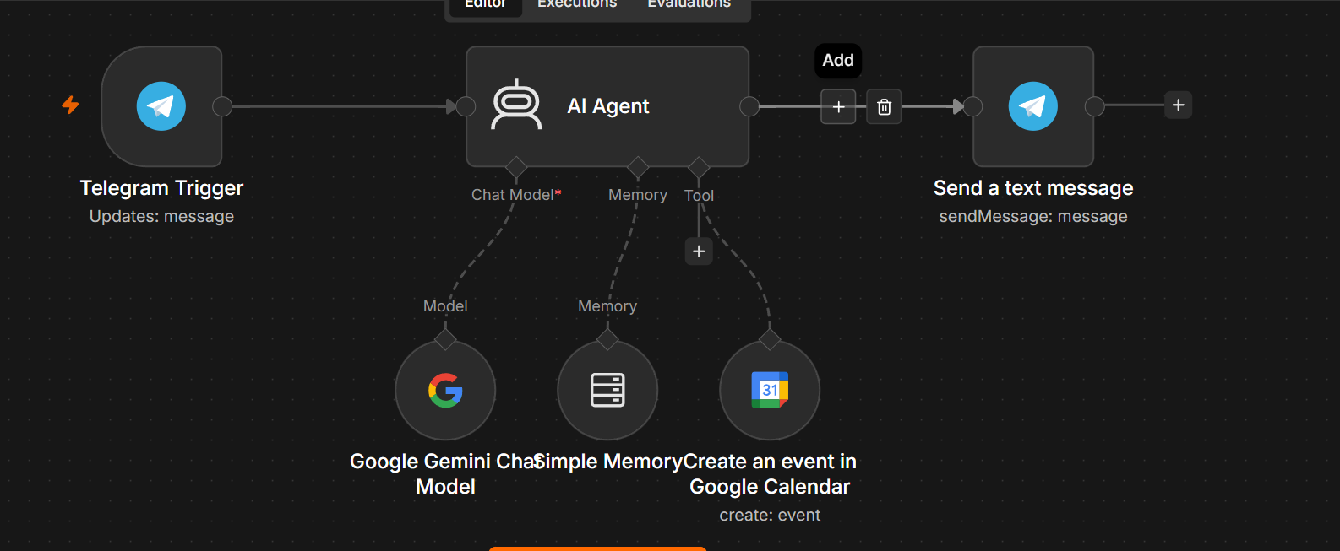
AI Telegram Calendar Assistant using n8n + Gemini
Overview
This workflow creates an AI-powered Telegram assistant that can understand natural language requests and create Google Calendar events automatically.
Example
User sends on Telegram:
Schedule a meeting with John tomorrow at 3 PM for 1 hour.
The AI understands:
- Event Title
- Date
- Time
- Duration
Then automatically creates the event in Google Calendar and confirms back in Telegram.

Workflow Architecture
Telegram Trigger
│
▼
AI Agent (Gemini)
│
├──────────────► Simple Memory
│
├──────────────► Google Calendar Tool
│
▼
Telegram Send Message

Workflow Components
1. Telegram Trigger
Purpose
Receives incoming Telegram messages.
Configuration
- Update Type
message
Output
{
"chat_id":123456789,
"text":"Schedule meeting tomorrow at 3 PM"
}

2. AI Agent
Purpose
Acts as the reasoning engine.
It
- Understands natural language
- Decides whether to use Google Calendar
- Sends response
Chat Model
Google Gemini Chat Model
Example
gemini-2.5-flash

3. Google Gemini Chat Model
Purpose
Provides the LLM.
Responsible for
- Understanding user intent
- Extracting event details
- Tool selection
Example Prompt
You are an intelligent personal assistant.

Whenever the user asks to schedule an event,
use the Google Calendar tool.

After creating the event,
confirm the booking politely.

4. Simple Memory
Purpose
Stores previous conversation.
Allows
User:
Move my meeting to 4 PM.

AI:
Which meeting?

User:
Today's meeting.
The AI remembers context.

5. Google Calendar Tool
Purpose
Creates calendar events.
Operation
Create Event
Required fields
- Summary
- Start Time
- End Time
Example Output
{
"id":"abc123",
"status":"confirmed"
}

6. Telegram Send Message
Purpose
Replies back to Telegram.
Example
✅ Your meeting with John has been added to Google Calendar.

Tomorrow
3:00 PM – 4:00 PM

Workflow Execution
User sends Telegram message

↓

Telegram Trigger receives message

↓

Gemini understands request

↓

AI decides

Create Calendar Event

↓

Google Calendar Tool executes

↓

Returns confirmation

↓

Telegram sends confirmation

Supported User Requests
Create events
Schedule a meeting tomorrow at 5 PM.
Appointments
Book dentist appointment on Friday.
Reminders
Lunch with Sarah at 1 PM.
Recurring meetings
Weekly team meeting every Monday.
Natural language
Meeting next Wednesday afternoon.

AI Agent System Prompt
You are an intelligent AI Calendar Assistant.

Your responsibilities:

• Understand natural language.
• Create Google Calendar events whenever the user requests scheduling.
• Ask follow-up questions if required information is missing.
• Use the Google Calendar tool to create events.
• Confirm successful event creation.
• Be concise and professional.

Required Credentials
Telegram
- Telegram Bot Token

Google Calendar
OAuth2 Credential
Permissions
Create Events
Read Events
Update Events

Google Gemini
Gemini API Key
Recommended model
gemini-2.5-flash

Example Conversation
User
Schedule project review tomorrow at 2 PM.
AI
Creating the event...
Google Calendar
Project Review

Tomorrow

2 PM–3 PM
Telegram
✅ Event created successfully.

Project Review

Tomorrow
2:00 PM–3:00 PM

Advantages
- Natural language scheduling
- Automatic Google Calendar integration
- Conversation memory
- Telegram interface
- AI-powered intent recognition
- No manual date/time parsing required
- Easy to extend with Gmail, Slack, Notion, or other tools

Skills Demonstrated
- AI Agent development in n8n
- Tool calling with Gemini
- Telegram bot automation
- Google Calendar integration
- Conversational memory
- Multi-service workflow orchestration
- Natural language processing (NLP)
This is a strong beginner-to-intermediate AI agent project and a good addition to a portfolio showcasing practical AI automation with n8n.

